### Contact Info

### Name: Michelle Tabor **Github (Capstone Repo): https://github.com/mtabor66/VMS**

**Your mentor is:**

### Initial Proposal

**Name of Project:** Volunteer Management System (working title of VMS)

**Brief Proposal:**

This Volunteer Management System will assist Organizations as a Contact Management System, a Project Tracker, and an Hours logger.

App Summary (After you get the 👍 on your paragraph proposal)

**Overview of app:**

**MVP Definition:**

Organizer Users will be able to post available volunteer opportunities. They will also be able to add to their volunteer list. They will be able to filter volunteers by skill, interests, and by ratings, and they will be able to add volunteers to projects that they have created. In the project, they will be able log each volunteer’s hours, rate volunteers, and create impact reports based off of inputed volunteer hours. Projects, volunteers, hours, and ratings will be able to be edited. Projects and Volunteers will able to be deleted.

**Dream Stretch Goals:**

Stretch Goals Part One: Organizers can email individually or in bulk volunteers from the app. Organizers can export impact/hour reports via csv.

Stretch Goals Part Two: Add a Volunteer Users.

Volunteer Users will be able to search for projects by location, interest and skill. They will be able to join or apply to be included in the project. They will report their hours, and will be able to leave feedback for the organizers after they’ve finished a project. Volunteers will be able to email Organizers. Volunteers can add a project to their Google Calendar.

Stretch Goal Part Three: Take emailing to an internal messaging system with email notifications if the user has a new message

**Things you want your mentor to check in on:**

Make sure I’m not going off into rabbit holes with extra details and features.

Make sure I hit MVP before I add features.

**User Stories (can be integrated into MVP definition or tickets):**

### Planning Links (required)

**Link to Repo Issues:**

https://github.com/mtabor66/VMS/issues

**Moqup/Wireframes:**

**ERD:**

[**https://www.draw.io/?lightbox=1&highlight=0000ff&edit=_blank&layers=1&nav=1&title=Teer%20VMS#Uhttps%3A%2F%2Fdrive.google.com%2Fuc%3Fid%3D1bA-_L3X9najZls4rXsgx5SEjEGmHjLIL%26export%3Ddownload**](https://www.draw.io/?lightbox=1&highlight=0000ff&edit=_blank&layers=1&nav=1&title=Teer%20VMS#Uhttps%3A%2F%2Fdrive.google.com%2Fuc%3Fid%3D1bA-_L3X9najZls4rXsgx5SEjEGmHjLIL%26export%3Ddownload)

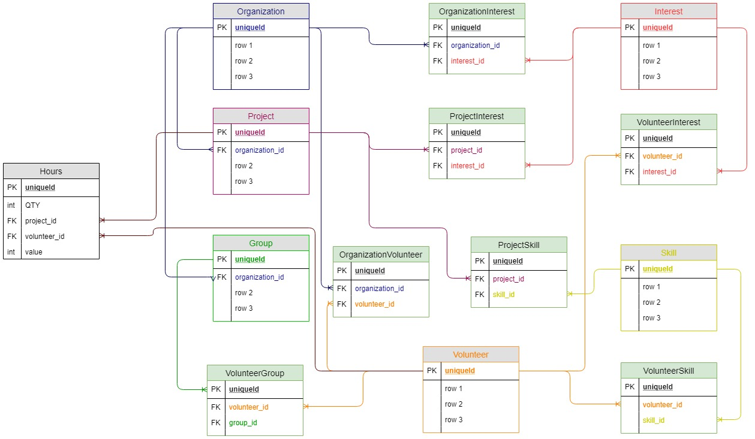

### 

### Research Planning Links or Documents

**I plan on using**

**Auth0**

**React**

**Bulma.io for styling**

**React -Moment for date stamps**

**I plan on using Be the Good, Points of Light, and Volunteer Match as inspirations.**